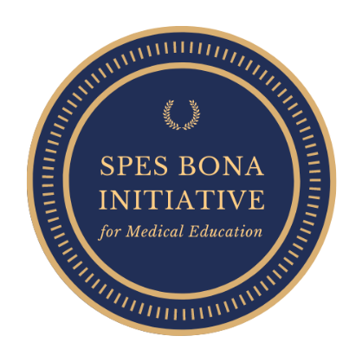

Vesalius Scholarship Application Form
This form must be sent to spesbonainitiative@gmail.com. Please note that clear copies of the following supporting documentation must be provided:
– ID document
– Curriculum Vitae (CV) accompanied by full academic record
– Parents/guardians proof of income (latest payslips or bank statements if employed/ affidavit if unemployed)
– Student’s motivation letter or video (recommended)
– Passport sized colour photo
– Declaration of income and expenses (see next page)
! Incomplete applications will not be processed !
Name :
Surname :
Date of Birth :
Email address :
Telephone Number:
University and year of study in 2022 :
Place of residence for the 2022 academic year :
I currently benefit from the following scholarships:
NAME | AMOUNT PER ANNUM

If awarded the scholarship, I authorize the Spes Bona Initiative to share my motivation letter or video as well as my picture on their website. I commit to provide the Spes Bona Initiative with quarterly reports including a certified copy of my mid-year and final academic results.
The Spes Bona Initiative reserves the right to suspend scholarship if the eligibility criteria are no longer met or for any other reason the selection committee would find rightful.
Date Signature

Name :
Date of Birth :
Declaration of income and expenses
Income per annum
Annual household income | ZAR
Student’s extra income if applicable (e.g. student job) | ZAR
Scholarships/bursaries | ZAR
Other (please specify: ) | ZAR
TOTAL INCOME | ZAR
Student’s monthly expenses
Accomodation | ZAR
Food | ZAR
Transportation | ZAR
Toiletries | ZAR
Stationery, textbooks,… | ZAR
Other (please specify : ) | ZAR
TOTAL EXPENSES | ZAR

I certify that the above information is, to my knowledge, complete and accurate.

Date Signature

